BIT 4107 – Mobile Application Development
ENHANCED PROFESSIONAL STUDENT LOGBOOK
Student Name: _ Cecily Ado
Admission Number: _BIT/2024/73846
School/Faculty: _School of Computing and Informatics
Programme: __BIT
Academic Year: ___2026
Semester: ___Year 3 Sem 2
Lecturer: __Mr. Nyoro
Phone Number: _0758989285

Instructions
This logbook is used to document weekly learning activities, practical exercises, skills acquired, challenges encountered, solutions applied, and reflections. Students should complete all sections every week.
Each week to follow remarks in week 1 section.

Autogenerated Table of content

Week 1: Introduction to Mobile Application Development
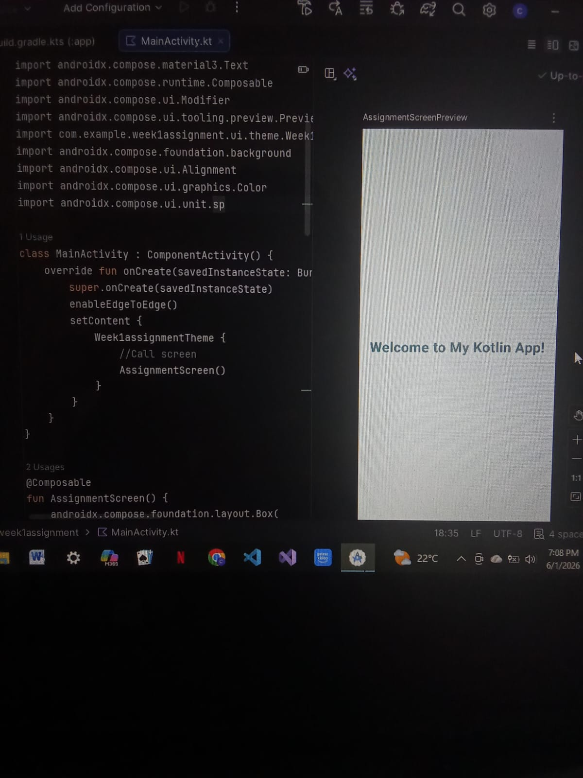

Practical Activities Undertaken
only screenshots needed and labeling
Screenshots/Evidence Attached (Yes/No)

Tools/Software Used

Used Android studio- Kotlin for the assignment and Flutter for the project

Personal Reflection
Android Studio and Flutter work together in that the IDE provides the heavy duty debugging and SDK engine while Flutter hands the UI magic. Getting them to cooperate on my limited PC was a hectic, RAM freezing nightmare but it was worth it.

Week 2: Mobile Development Environment
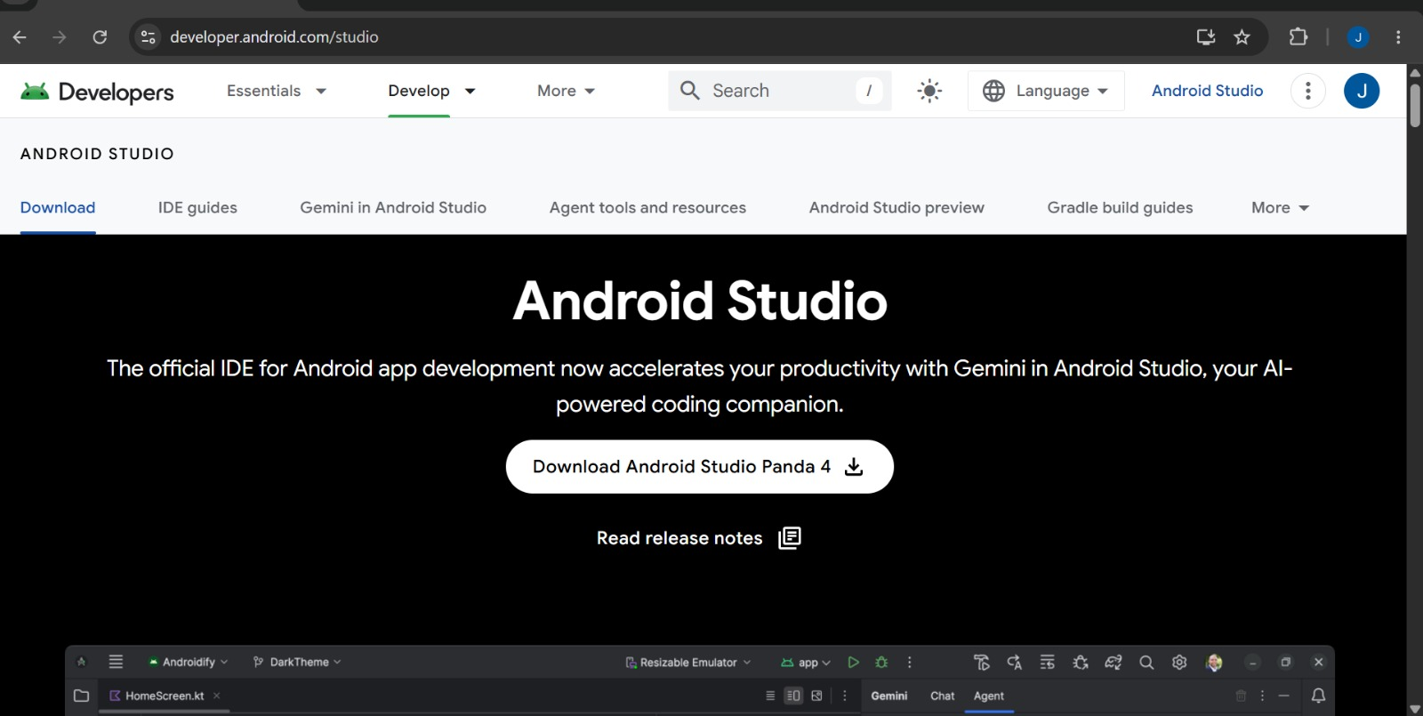
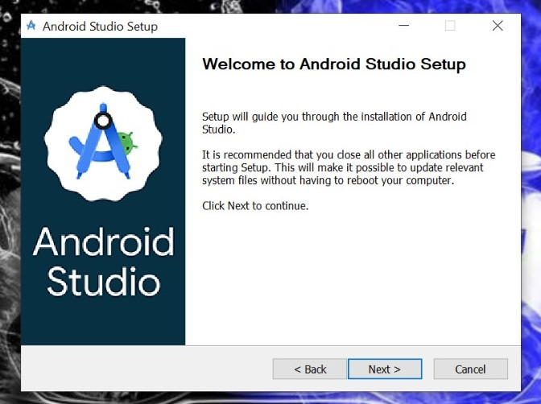
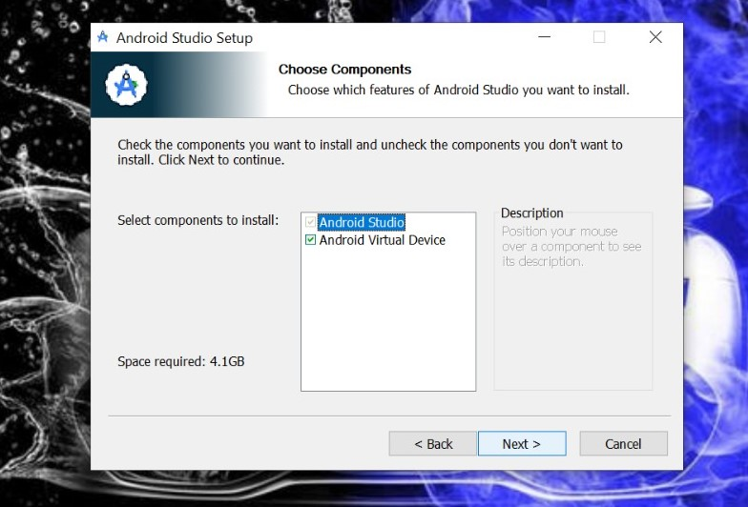
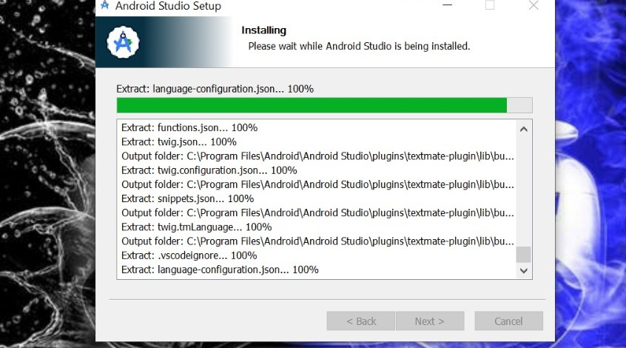

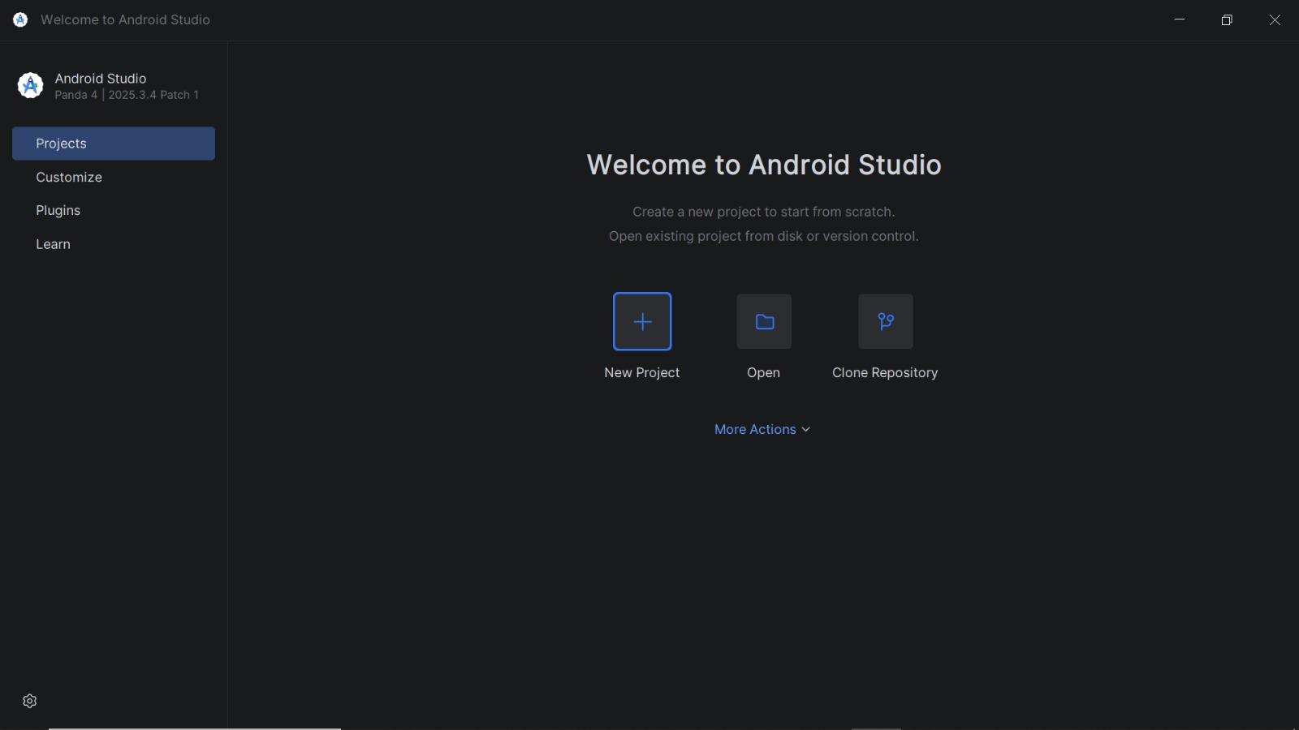

Flutter plugin
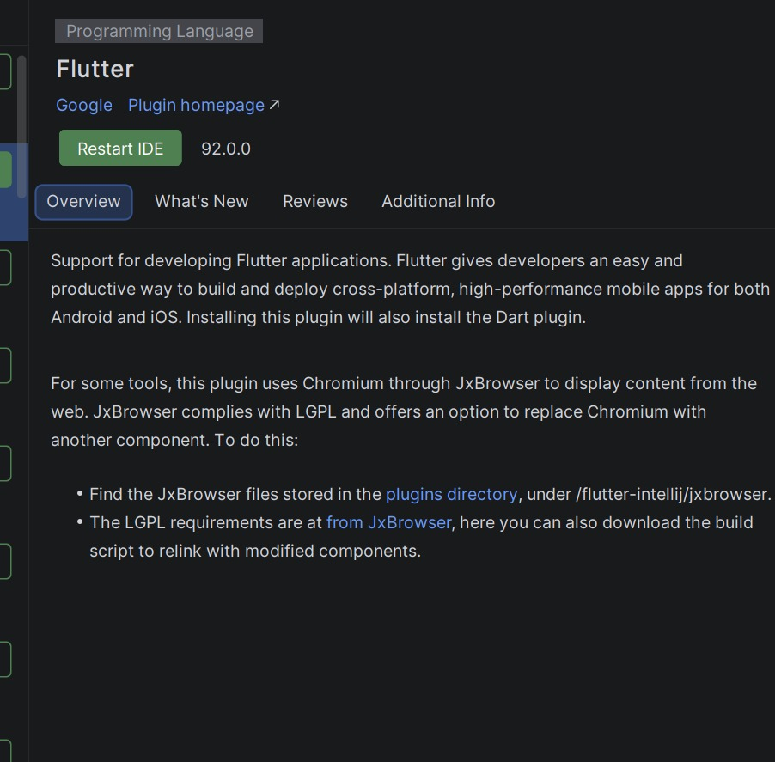

Flutter setup
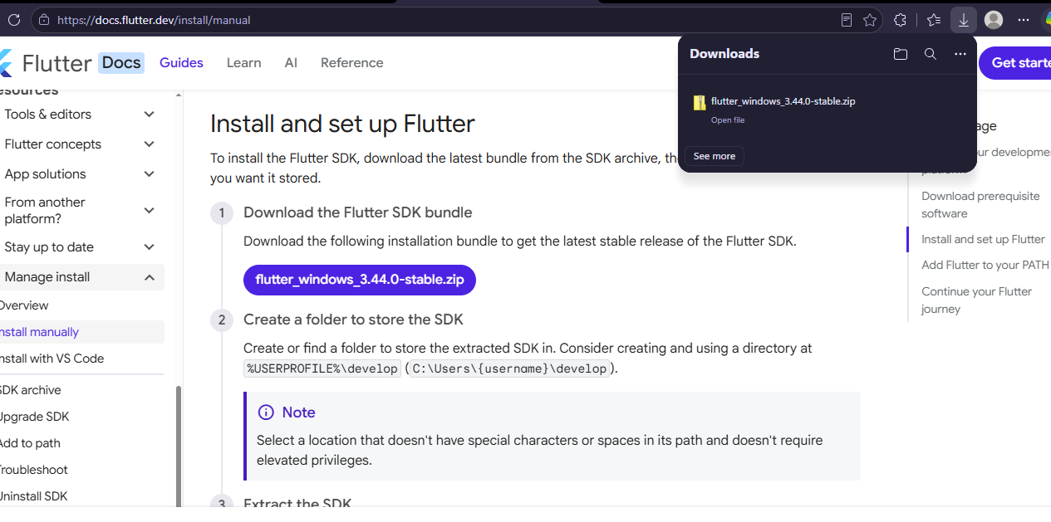
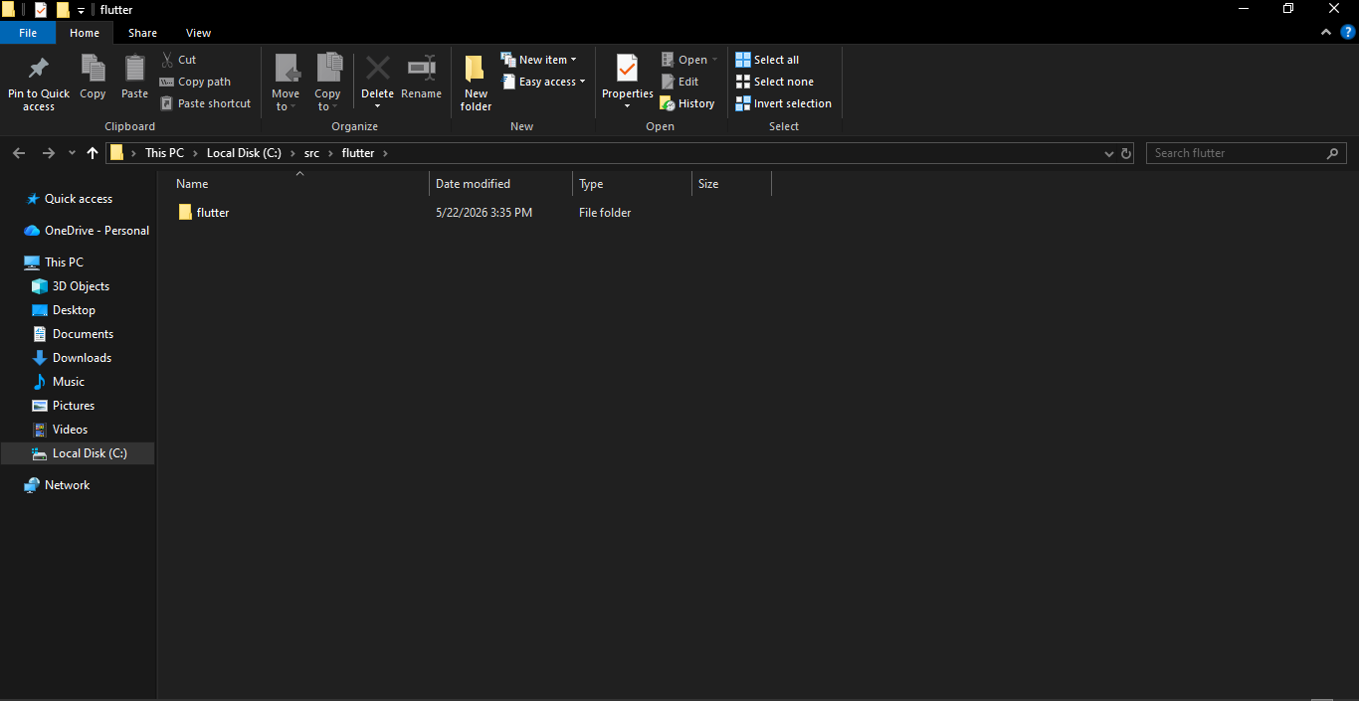
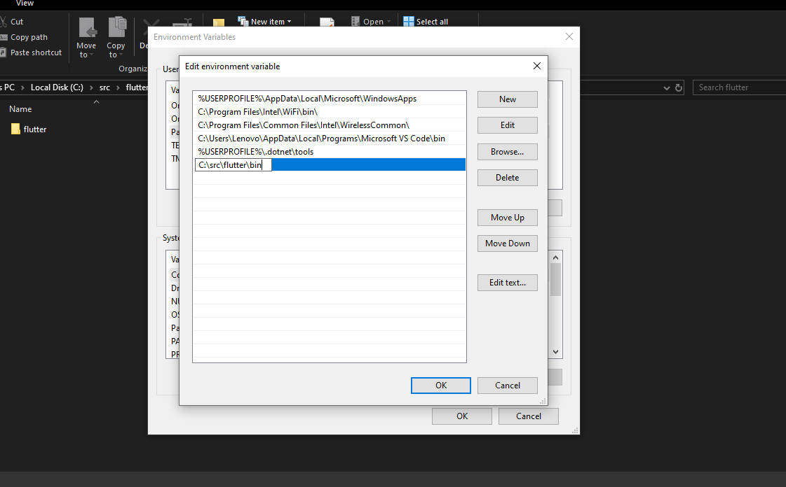
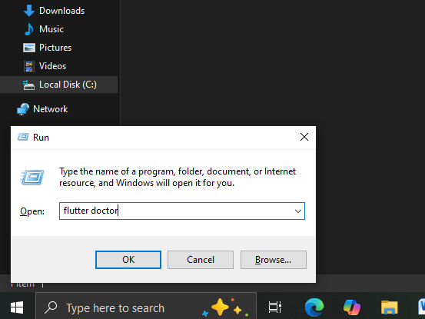
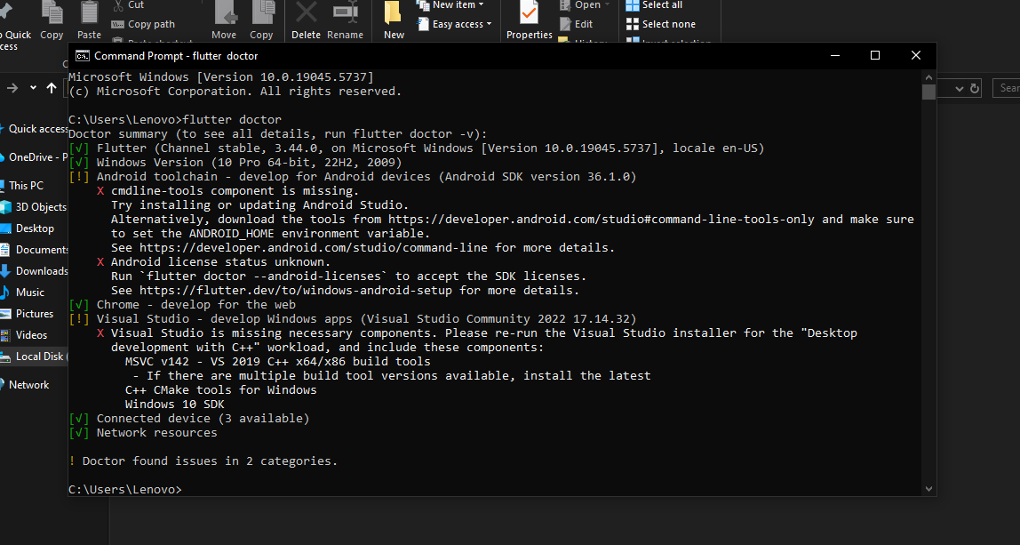
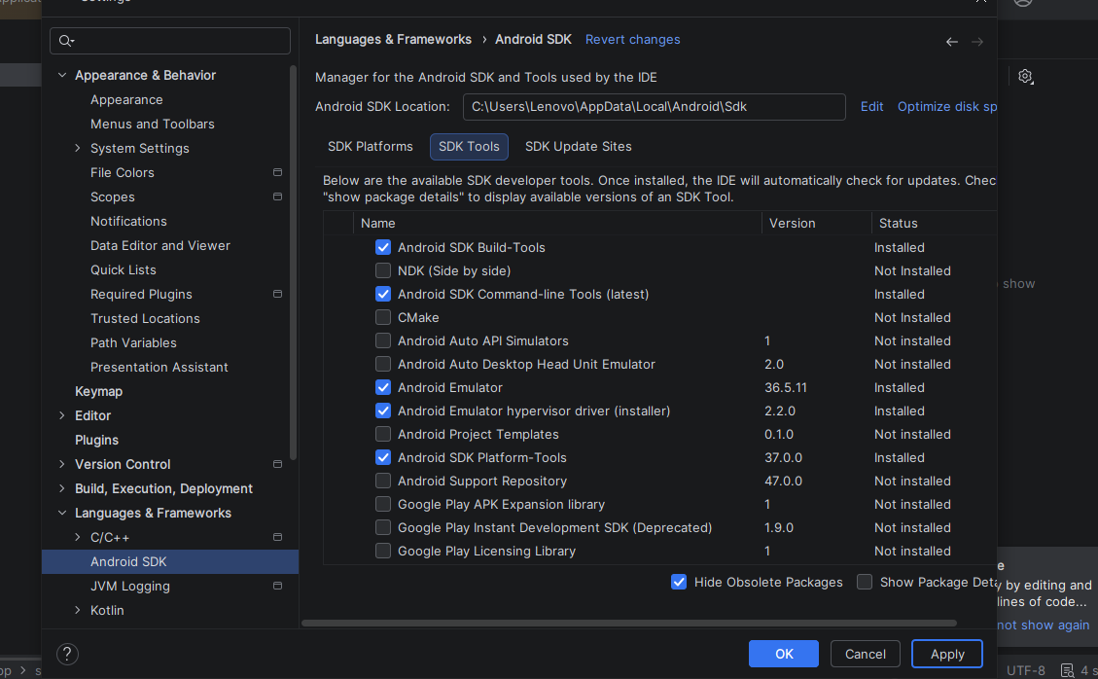
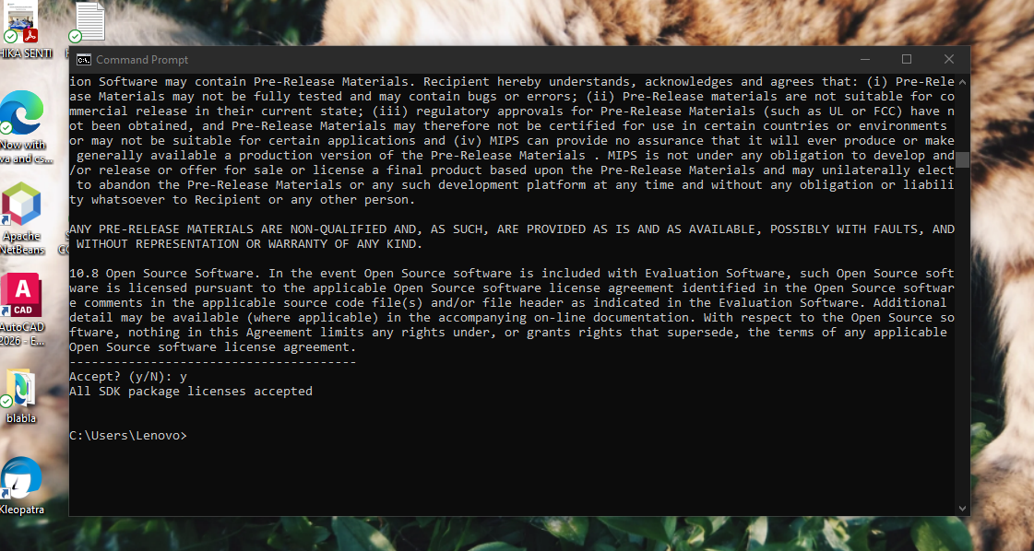
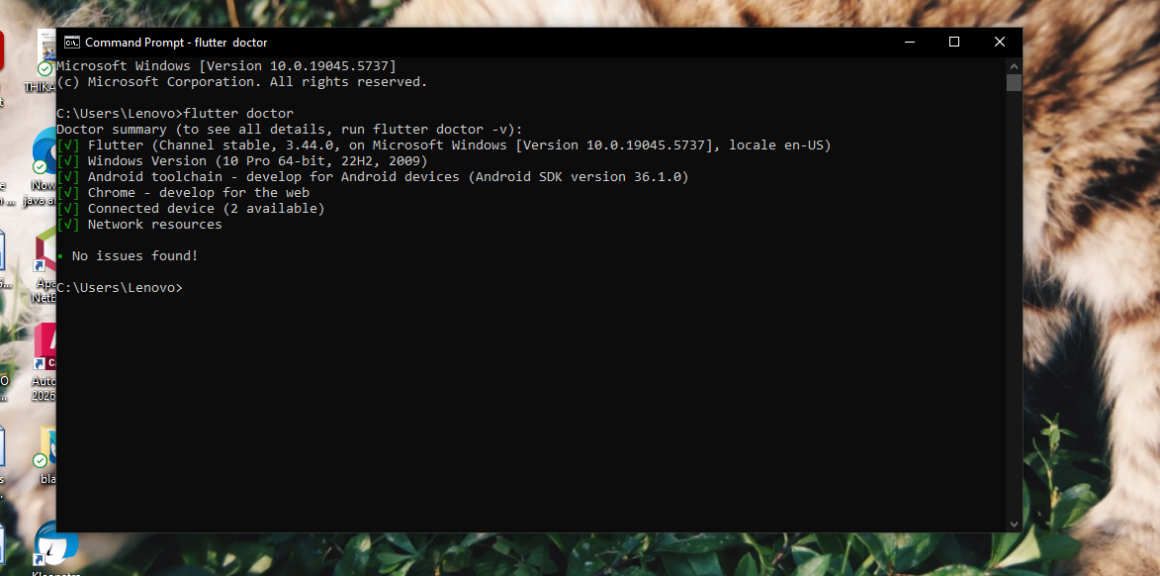
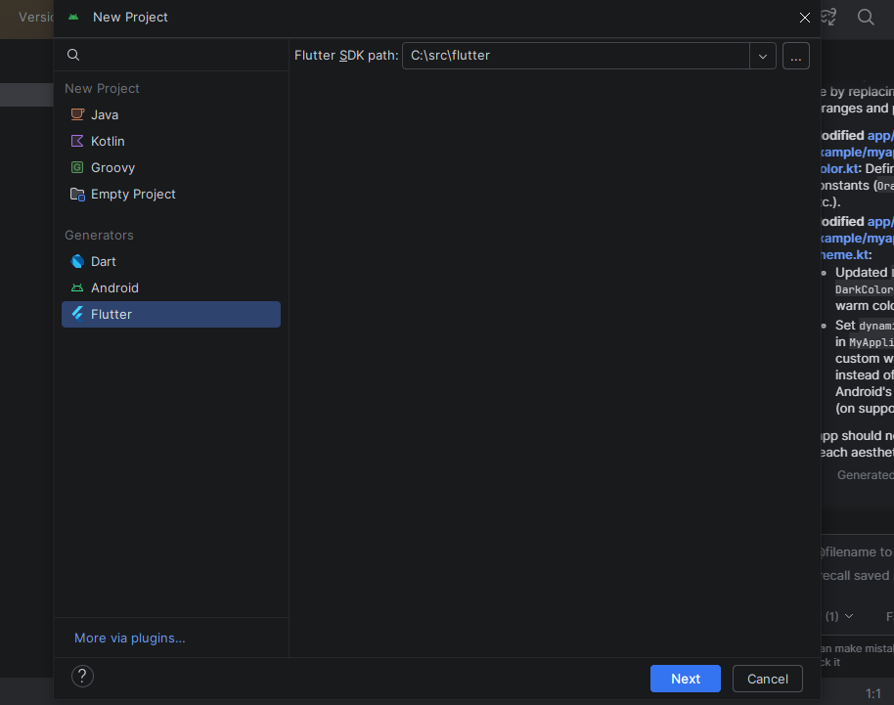
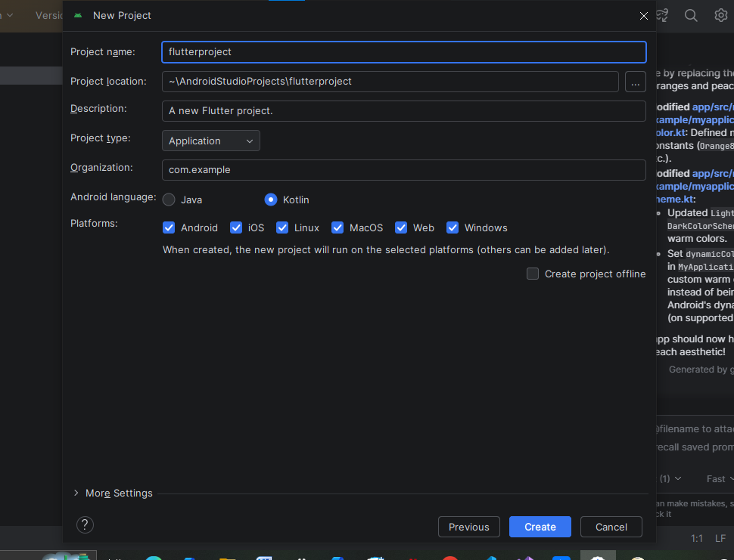
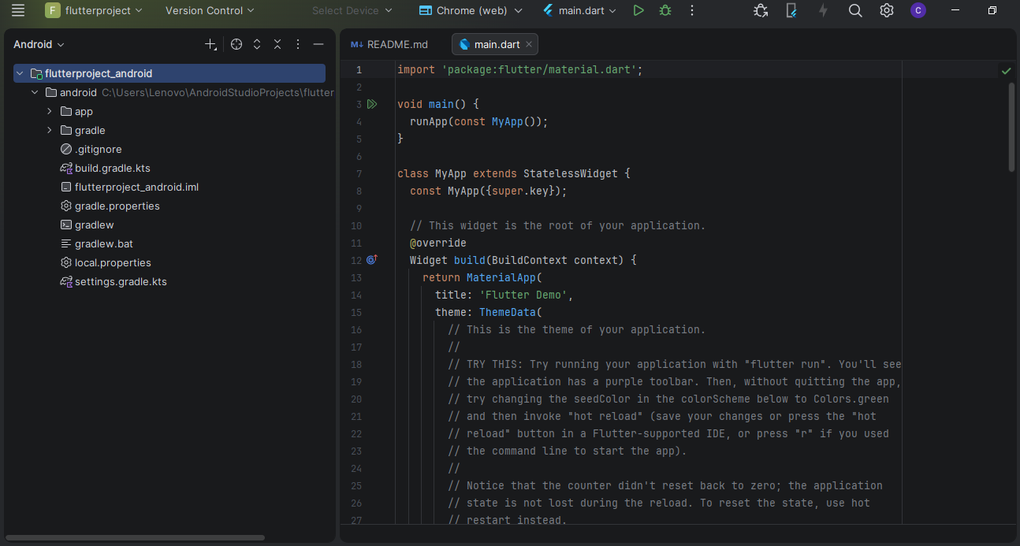

Week 3: User Interface Design
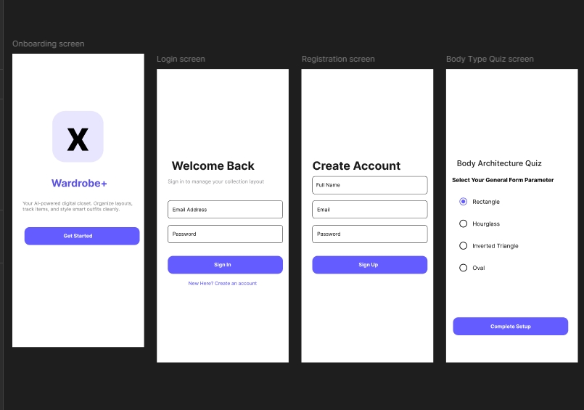
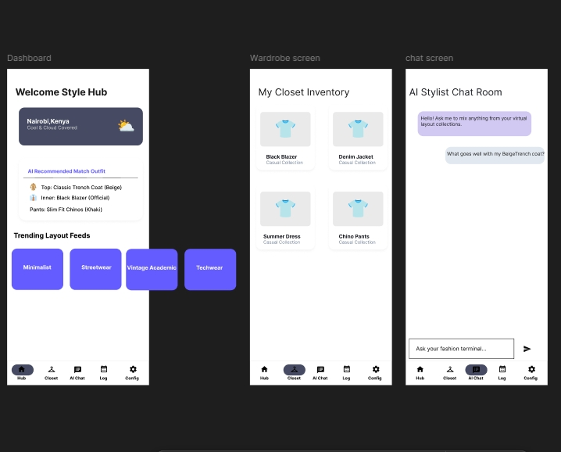
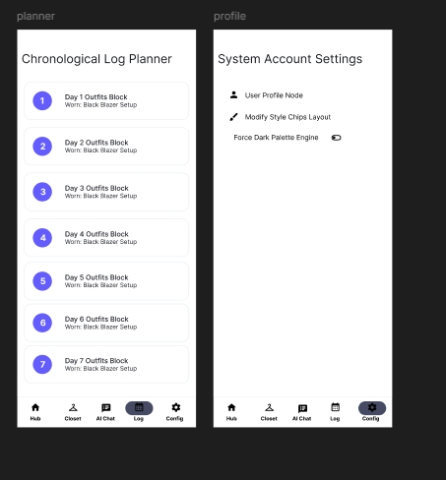

Week 4: Event Handling and User Interaction

Same as week 1

Week 5: Data Management

Same as week 1

Week 6: Networking and APIs

Same as week 1

Week 7: Application Architecture

Same as week 1

Week 8: Project Planning

Week 9: Device Features and Sensors

Same as week 1

Week 10: Notifications and Background Services

Same as week 1

Week 11: Mobile Security

Same as week 1

Week 12: Testing and Debugging

Same as week 1

Week 13: Application Deployment

Same as week 1

Week 14: Final Project Presentation

Same as week 1

Semester Project Tracking

Project Title

Project Objectives

Project Requirements

Development Milestones

Testing Results

Lessons Learned

Future Improvements

End of Semester Reflection

Summary of Skills Acquired

Most Interesting Topic

Major Challenges Faced

How Challenges Were Overcome

Professional Growth Achieved

Overall Course Experience

Final Approval
Student Name: __________________________
Student Signature: ______________________
Date: _________________________________
Lecturer Name: _________________________
Lecturer Remarks: _____________________
Date: _________________________________

